Minutes of the Council meeting held on:
Wednesday 18th January 2023 at 6.30pm
In Udimore Community Hall.

Present: Cllr. G. Quinnell (Chair), Cllr. N. Anderson, Cllr. D. Gibbs, Cllr. G. Rothery and Dist. Cllr. N. Gordon

- Apologies.
Apologies were received from Cllr. R. Mair and Cty Cllr. Carl Maynard.

- Disclosures of Interest.
There were none.

- Reports from District and County Councillors.
Cty. Cllr. Maynard had sent a written report which is attached at Appendix 1. Dist. Cllr. Neil Gordon reported that the Town Hall project was on hold, and it was likely that the Council would need in the region of £2M from it’s reserves in the coming year.

- Minutes from the previous meeting.
The minutes of the Full Council Meeting held on 16th November 2022 were agreed.

- Highways.
  - Potholes. Concern was expressed at the size of the pothole outside The Laurels.
(Clerks Note: Reported on the Highways Site – Report A Problem)
  - Bus Shelter. Clerk has asked Highways if they would remove the dangerous structure.
  - Old Post House Edge. More drainage works are scheduled to be carried out shortly.
  - Dumb Womans Lane Verge and Drainage Works. The Highway Steward had reported that they did not meet the criteria for action.

- Planning.
  - Planning – RR/2022/2587/P Kings Head. The members felt that the extension would improve the viability of the business and as such they agreed to support approval, and to request that Cllr. Gordon call the decision in should it not be approved.
  - Results. – There were none.
  - Enforcement – The Clerk was asked to contact Mark Bright (Enforcement Officer) regarding the activities of Avocado Outdoors (adjacent to Udimore Road, between Sowdens Oast and the Kings Head).
  - NPPF Consultation. Councillors are asked to comment individually; the Clerk will forward a link to the consultation.

- Finance.
- Bank Statement. The Council resolved to accept the Bank Statement for November and December 2022.
- Bank Reconciliation. The Council resolved to accept the Bank Reconciliation for November and December 2022.
- Payment Schedule. The Council resolved to accept the Payment Schedule:

Date | Payee | Gross | VAT | Net
28/12/22 | ICO (Information Commissioners Office) | £35.00 | £0.00 | £35.00
18/1/23 | R. Franklin – Clerks Pay & Exps. | £550.36 | £0.00 | £550.36
18/1/23 | HMRC | £120.80 | £0.00 | £120.80

- Budget v. Spend. It was noted this was on target.
- Internet Banking Signatures. Cllr. Anderson has completed his application form.
- Street Lighting Finance. The Chair agreed to visit the resident who appears to be paying towards the street lighting which is paid for by the Parish Council.
- Udimore Community Fund. It was reported that this is now being paid into the Business Bank Instant account and now stands at £386.50. This is available for community projects.

- Playground.
  - Safety Check. The Chair confirmed he is carrying out the monthly safety checks.
  - Repairs from the Annual Inspection. The minor faults are still awaiting an engineer’s visit.

- Action Plan Review.
It was agreed that the current 2010 Action Plan should be reviewed, and a revised Action Plan produced for the March meeting. Cllr. Gibbs agreed to lead on the review. Councillors to exchange comments/ideas by email.

- Provision of New Finger Post.
A new arm has been constructed and will be fitted shortly.

- St. Mary’s Community Hall.
  - Funding. No action at present.
  - Committee Membership Report. Cllr. Anderson reported that there does not appear to have been any meetings so far.
  - Hall Parking. Cllr. Anderson agreed to prepare some plans for maximising the parking spaces and to obtain some outline costs.

- Correspondence from the Clerk.
The Clerk reported an invitation had been received from the Grumpy Chef organisation, but it was felt that there was not a requirement in the Parish for this.

- Items for Inclusion on a Future Agenda.
  - Coronation Planning.
  - Elections.
  - Fly tipping.
  - Newsletter

- Date of Next Meeting.
15th March 2023 - 6.30pm, at Village Hall

The meeting was closed at 7.30pm.

……………………………………………………………
Signature of Chair.

APPENDIX 1.

County Report for Jan 2023 from Cllr Carl Maynard

Communities, Economy and Transport

Historic proclamation document to be displayed in County Hall

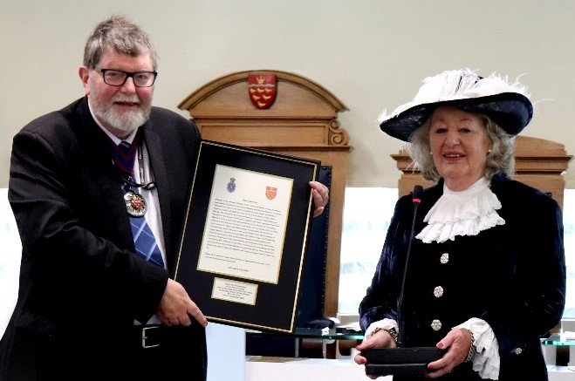On the 6th of December, the High Sheriff of East Sussex presented a framed version of the proclamation of King Charles III to the Chairman of East Sussex County Council, Councillor Peter Pragnell. The proclamation was presented at the start of Full Council, and will go on display at County Hall.

The proclamation contains the words which were read from the steps of County Hall in September to proclaim the new King after the death of Queen Elizabeth II. The High Sheriff, Jane King, said she wanted to present the gift as ‘a reminder and souvenir of that very momentous day’. The council plans to display the document in a place which will allow as many people as possible to view it.

Environmentally-friendly gritters ready for winter in East Sussex

Gritters running on low emission biodiesel will be working to keep East Sussex moving safely this winter. Preparations are underway to ensure the 21 ‘green’ gritters are ready for snow forecasts or when the road surface temperature falls near to or below freezing.

The vehicles and their drivers were recently tested during Operation Snowdrop, an annual event which allows the gritters to be thoroughly checked and sent on trial runs of the county’s gritting routes. In addition to the gritters, the Highways team has over 9,500 tonnes of salt stored in four depots across the county, with 766 grit bins countywide refilled over the summer for use on public roads and footpaths.

Over the winter, the gritters will treat all A and B roads along with some C roads – a total of 42 per cent of roads across the county, with over 1,252km of roads treated on a primary route gritting run.

More information on this story can be found here.

Safety advice for drivers and the East Sussex Highways winter service is available here.

Any problems on the roads can be reported online here.

School closure updates can be found here, and other information concerning disruption to council services can be found on the East Sussex news page.

Refurbishment projects announced for three libraries

Improvements to three East Sussex libraries mean that customers will find it even easier to access services. Work will take place in Rye, Newhaven and Hollington to improve their layout to enhance customer experience, with children’s areas and study spaces being upgraded and new seating installed. The improvements will support the library service to deliver its aims, including improving child and adult numeracy and literacy.

The schemes will also help to reduce the libraries’ carbon footprints with a range of improvements to the buildings themselves. Work at Rye Library began last month with a new children’s library planned, new furniture, an improved layout and more flexibility for customers to stay, enjoy and study within the space.

Extensive refurbishment work will begin at Hollington Library later in the spring, with a range of works being undertaken to update the building. Details of any closures will be advertised in libraries and online as soon as they have been confirmed.

Apprenticeship training funding boost

Funding to cover the full training costs of an apprenticeship is being made available to small and medium sized enterprises (SMEs) across the county. Through the council’s Apprenticeship Levy transfer scheme, the Transform programme is offering small and medium businesses in East Sussex the chance to apply for a share of over £300,000.

The Transform project aims to help SMEs in East Sussex access apprenticeship advice and funding and is part-funded by the European Social Fund and led by East Sussex County Council. It is delivered by the Sussex Council of Training Providers (SCTP).

Apprenticeships offer an opportunity for people to take the first steps onto the career ladder, change career paths or develop new skills in a current role, earn money while training and gain qualifications from entry level to the equivalent of a master’s degree. Several local businesses have already benefitted from the advice and support offered by SCTP’s Transform Skills Advisers.

Small and medium enterprises in East Sussex that would like support accessing apprenticeships and apprenticeship funding should contact transform@sctp.org.uk for further information.

Businesses can also visit the Sussex Council of Training Providers website to access the free and impartial Transform skills support service at www.sctp.org.uk/transform-programme.

