Minutes of the Council meeting held on:
Wednesday 16th March 2022 at 6.30pm
In Udimore Community Hall.

Present: Cllr. G. Quinnell, Cllr. R. Mair, Cllr. L. Weaver

- Apologies.
Apologies were received from Cllr. J. Johnson, Cllr. G. Rothery and Cllr. Carl Maynard.

- Disclosures of Interest.
There were none.

- Reports from District and County Councillors.
No reports were received.

- Minutes from the previous meeting.
The minutes of the Full Council Meeting held on 19th January 2022 and of the Extraordinary Meeting held on 16th February 2022 were all agreed.

- Traffic.
  - Confirmation of Speed Checks. It was confirmed that two speed checks would be carried out at a cost of £710.00 plus VAT.
  - Confirmation of Speed Feasibility Study and location of speed surveys to support application. A response had been received stating that the first step would be Speed Survey (s) costing £420.00 plus VAT for one or £710.00 plus VAT for two. Locations to be advised by Highways.
  - Latest information on Surfaces outside Old Post House and Churchfield Cottages. A subsequent report has been raised with Highways Customer Services stating that the interim cures have not worked.
  - Latest Statement on Provision of Mirrors. Highways responded to our request stating that they did not consider mirrors to provide adequate safety and that the other end of Dumb Womans Lane is adequately covered by the existing signage.

- Planning.
  - RR/2022/188/P. Newmans Oast, Udimore Road TN31 6BG. Removal of timber balcony structure, replacement of all windows, replacement of weather boarding and alterations to window opening sizes.
Council agreed to support approval.
  - RR/2022/3/P. The Lindens, Udimore Road, TN31 6AY. Erection of a single storey timber framed double garage to the front of the existing property.
Council agreed to support approval.

- Finance.
- Bank Statement. It was resolved to accept the Bank Statements for January and February.
- Bank Reconciliation. The Council resolved to accept the Bank Reconciliations for January and February.
- Payment Schedule. The Council resolved to accept the Payment Schedule:

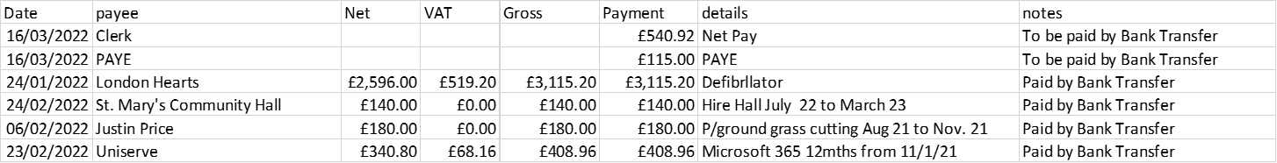

- Budget v. Spend. It was noted this was on target, and there would be some transfers to earmarked reserves at the end of the financial year.
- Internet Banking Signatures. It was believed that in order to become an Internet Banking signature, Cllr. Davis first needed to be an actual signature and the forms for this were signed by Cllrs. Quinnell and Weaver. It was noted that at present the account is being run requiring only the Clerks signature.

- Playground.
  - Update on the Situation by the Chair. The Chair reported that the play apparatus is considered satisfactory.
  - Monthly safety checks. The Chair reported that these were being carried out and no training course as yet available.

- Provision of Defibrillators.
The Chair reported that defibrillators are available from behind the bar at The Plough and inside the Church when they are open, until the cases arrive.
Unfortunately the training on the use of the defibrillators had to be cancelled due to the trainer catching Covid-19 and it is hoped to rearrange this for the May meeting.

- Platinum Jubilee Preparations.
Preparations are going ahead for a Celebration on Friday 3rd June. A donation has been promised from Rother District Council for £500.00 and the Council resolved to also contribute £500.00. It was also resolved that the Clerk should purchase two x ten metres of Jubilee bunting.

- Correspondence to the Clerk.
There was no correspondence.

- Clerk’s Pay.
It was agreed that the Clerk should receive the backdated pay due from the 1st April 2021 and that the Clerk should move to Salary Scale 7 from the 1st April 2022.

- Items for inclusion in the next meeting Agenda.
  - Annual General Meeting.
  - Annual Parish Assembly.
It was resolved that the Clerk would provide wine and refreshments.

- Date of Next Meeting.
Wednesday 18th May 2022. It was proposed by Cllr. Mair and agreed by the Council that the time of the next meeting should be moved to 7pm.

The meeting was closed at 7.15pm.

……………………………………………………………
Signature of Chair.

