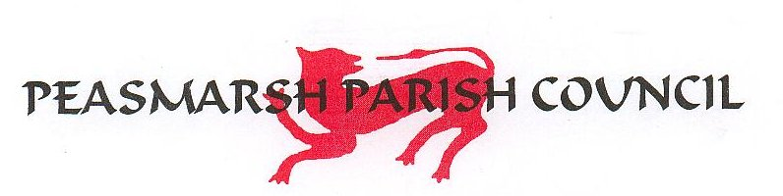
Minutes of the Council meeting held Wedneday 1 July 2026 at 7.30pm at Peasmarsh Memorial Hall.

Present: Councillors: Ben Randall (BR) (Chairman), Georgina Dunham (GD), Marcus Gould (MG), Gina Sanderson (GS), Peter Lamont (PL), Rose Kiley (RK).
Also present: Clerk and RFO Nick Brown (NB), County Councillor Paul Redstone (PR) and District Councillor Paul Oborne (PO)

45. Apologies for absence – Councillor Robert Barham
46. Disclosure of interests under the Council’s Code of Conduct – None
47. Minutes of the last Council meetings – 3 June 2026 - agreed and signed by the Chairman. There were no members of the public present.
- Village Steward. The Council resolved to appoint Chris Prior as the Village Steward on a monthly retainer of £200. It was further resolved to empower the Clerk to authorise small maintenance jobs on an ad hoc basis. Cap on expenditure is £1000. Initial jobs include painting the skate park equipment to cover the offensive graffiti. The Steward has been issued with bin liners and litter pickers and will provide at his own expense a hi-viz jacket identifying him as affiliated with the Parish Council. The clerk will also procure new signs reiterating that dogs, quad bikes, e-bikes etc are NOT ALLOWED on the Rec. It was noted that the prohibition on dogs is routinely ignored but it is difficult to police this.
- The Pavilion. Discussion around the condition of the Pavilion. The Clerk will circulate a list of possible dates for a clear-out. Much of the contents of the cupboards can be disposed of and anything which needs to be kept can, for the time being, be transferred to the shipping container at the rear of the pavilion. Quotes for a deep clean are being obtained and the whole operation will be carried out before the next PC meeting in September.
- Nature Walks and Village Pond. RK has contacted Sussex Wildlife and they assured her that the would be interested. GD will also approach Sue Cavella who has an interest in this. The aim is to organise an Autumn Walk for later in the year. RK will speak to residents in the vicinity of the Pond. Ownership is uncertain but according to PR the land appears to be unregistered. He will investigate further. The Clerk will investigate possible grants for refurbishment of the Pond.
- Village traffic and roads – PL supplied a written report. Traffic has been heavier over the past month, probably due to road closures on the A21 and A268. The 85th percentile average speed towards Rye was 36.1mph and towards Beckley was 33.67mph.
- Clerk’s Report. Keys distributed. The Clerk was authorised to apply to open a Current Account at Unity Bank to replace Lloyds. Lloyds have proved highly unsatisfactory in terms of their response to complaints. The request for a Fair will be declined due to the sinkhole repairs from last year and further details will be requested.
- County Councillor’s Report. PR discussed the budgetary constraints around roads maintenance. There is a total budget of £24m for 2000 miles of roads in the County area. By comparison, repairs to Junction Road alone will total £1-1.5m. A decision should be made on local government by the end of the Parliamentary session on July 17 but, given the current situation around the appointment of a new Prime Minister, there is no certainty. It was nted that the supposed incoming PM has emphasised his interest in devolution
- District Councillor’s Report. There has been speculation around the replacement of Council Tax with a Land Tax – watch this space.
- AGAR.

55.1 Read and approved

55.2 Read and approved

55.3 Read and approved

55.4 Mulberry confirmed as Internal Auditor for FY26/27

56.1 Reconciliations approved.

56.2 Annual Grant and Donations. A donation of £250 to KSS Air Ambulance was agreed.

A donation to RNL was considered; the Council felt it would be more appropriate for a donation to be made locally rather than to the national organisation – to investigate.

East Sussex Vision Support will be approached for further details.
  - All payments approved

57. Planning Matters – no comments.

The meeting closed at 8:52 pm.

