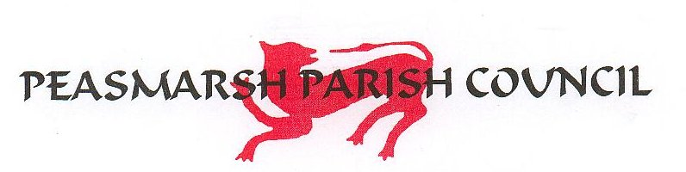
Minutes of the Council meeting held Wedneday 1 July 2026 at 7.30pm at Peasmarsh Memorial Hall.

Present: Councillors: Ben Randall (BR) (Chairman), Georgina Dunham (GD), Marcus Gould (MG), Sanderson (GS), Peter Lamont (PL), Rose Kiley (RK).
Also present: Clerk and RFO Nick Brown (NB) and District Councillor Paul Oborne (PO)

29. Apologies for absence – Councillor Robert Barham, East Sussex Councillor Paul Redstone
- Disclosure of interests under the Council’s Code of Conduct – None
- Minutes of the last Council meetings – 6 May 2026 - agreed by all subect to an amendment re the Clerk’s Report and signed by BR. There were no members of the public present.
- Parish Councillors – Unfortunately both prospective candidates withdrew their applications before the meeting. We remain two councillors short of a full complement and will advertise again. A member of the public raised the issue of a caretaker and this is covered under Item 34.
- The Parish Assembly. General discussion. Next year we will advertise with banners on public roads in the village. Will try to get a special guest to address the Assembly.

In terms of regular village events to mark the seasons, the following were suggested: Christmas Tree, Litter Pick in April, Guided Walks for the summer.

The village pond needs refurbishing and we will try to find out who owns or has responsibility for it. RK will investigate and will report back.
- The Pavilion. General discussion. The Pavilion is rather dilapidated and needs a deep clean inside. This led to a discussion about village jobs in general and maintenance on the Rec in particular. RESOLVED: The Clerk will negotiate with Chris Prior who has expressed his willingness to act as the Village Steward. There is a lot of football stuff in the lockers in the Pavilion and a date will be agreed to have a clear out. Similarly, the storage container behind the Pavilion is full of lining equipment, goal posts etc. and will need cleaning out. RESOLVED: The Clerk will try to find out who the equipment belongs to and the Council will try to co-ordinate a session for clearing it out. The Clerk will get a deep cleaning firm to clean the Pavilion, including the contents of the cupboards in the kitchen.

36. Village traffic and roads – PL supplied a written report. The police are interested in the VAS data as well as the Black Cat data, which they say they find useful.

37. Clerks’ Report. New keys will be cut and distributed for the various doors and gates around the Parish. There will be a fire alarm inspection of the Pavilion on 8 July.
- Financial Matters – We are having considerable problems with Lloyds Bank. RESOLVED: The Clerk to investigate moving the current and deposit accounts to Unity Bank, which is used by many other Parish Councils.
- Planning Matters – Kitewood - GS reported on the Planning Committee meeting in Bexhill were RDC resolved to refuse the existing application and suggest the developer thinks again. Major issues included ground and surface water and sewage. RDC wants an absolute guarantee from the Water company that they have capacity and won’t jyst release foul water through normal sluice gate procedures. RDC wants the Environment Agency, Southern Water and the Parish Council to be actively involved in any further discussions with the developer to ensure that a revised application meets the concerns of all parties.

RDC complimented the Parish Council on the quality and clarity of their submission on the Kitewood application. The Council minuted its thanks to the previous Clerk, Amy Head, for all her hard work on this; and also thanked Gina Sanderson and all those who worked on the submission.

The meeting closed at 9:10pm.

