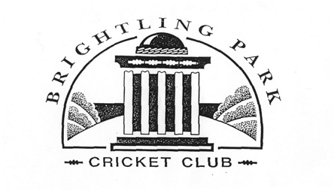

Report for the Brightling Annual Village Meeting – 8th April 2026

The village cricket club plays home games in the idyllic setting of Brightling Park and has done for many years. Like many neighbouring clubs, consistently finding 11 players every week throughout the season can be a struggle and new players are always welcome. That said, The Park had an excellent 2025 season winning the Village Tournament for the first time.

The club recently held its AGM (26th March) and the following officers were elected:

- Chairman – Gardie Grissell
- Treasurer – Melanie Richner
- Hon Sec – Steve Leeves
- Hon Fixture Sec – Ricci Kent
- Captain – Sam Richner
- Vice – Seb Stovell
- Umpire – Neil Pope
- Groundsman – Matt
- Scorer/Media – Maisy Evershed

The fixtures for the season were also presented:

NB: fixtures marked with * are Village Tournament matches.

Date | Opponent | Venue | Time
Sunday May 10th | Crowhurst * | Away | 13:30
Sunday May 17th | Ashburnham * | Away | 13:30
Sunday May 30th | Heathfield Park | Away | 13:30
Sunday June 7th | Ashburnham * | Home | 13:30
Sunday June 14th | Catsfield * | Home | 13:30
Sunday June 21st | Mountfield * | Home | 13:30
Sunday June 27th | Northiam | Away | 14:00
Sunday July 12th | Hurst Green | Away | 13:30
Sunday July 19th | Mountfield * | Away | 13:30
Sunday July 26th | Battle | TBC | 13:30
Sunday August 2nd | Catsfield * | Away | 13:30
Sunday August 9th | Late Nighters | Home | 13:30
Sunday August 16th | Burwash Village | TBC | 13:00
Sunday August 23rd | Bodle Street | Away | 13:00
Sunday August 30th | Harry Wills XI | Home | 13:30
Sunday Sept 6th | Crowhurst * | Home | 13:30

Membership

Membership of the club is via a £30 annual subscription. Players also pay a £5 match fee.

Non-playing members are also very welcome and are invited to become Vice Presidents of the club upon a donation of at least the annual subscription.

Funding

Running a cricket club, even on a relatively small village basis, is not an easy task and maintaining the ground is probably the largest expense annually.

At the close of last season it was clear that the wicket needed some attention which was carried out by way of scarifying, loaming and seeding the whole square. Similar work is required before the start of the season along with weed killing.

Mowers often appear as the highest annual expense in the club accounts and for this season it looks like that tradition will continue. The mower used on the square needs some maintenance (£120-150) and unfortunately the ride on mower used for the outfield needs replacing. Fortunately the club Chairman, Gardie, has kindly offered the use of his in the interim.

Fund Raising

In addition to subscriptions and Vice President donations the club looks to find other avenues for fund raising. Traditionally pub quizzes have proved successful and Ricci Kent has arranged one for Wednesday 6th May at the Half Moon in Cade Street. Teams of up to 8 people can enter at a cost of £30 per team. Food isn’t provided however prizes will be awarded for the “best team buffet” of the evening. The usual raffle will also run.

In Conclusion…

It is hoped that cricket at The Park will continue for many years to come. For this to happen it will of course need a steady stream of new/additional players along with people happy to carry out the admin of the club.

Other avenues of funding will be looked at in the coming months along with a Vice President recruitment drive!

If anyone reading this would be interested in getting involved with the club in any capacity please do make yourself known to any of the officers.

Steve Leeves
Hon Sec
BPCC
spleeves@gmail.com

